Name

Mathematics Extension 1 Year 12
Further Rates of Change

Book 2 |  | Version: 261020  Feedback:  https://MrDingMaths.com
Contents
Syllabus Content 2
Learning Intention 8

Syllabus Content
ME1-12-05 applies calculus to solve problems involving polynomials, further rates of change, areas and volumes and differential equations
Further rates of change
- Develop models in contexts where a rate of change of a function can be expressed as a rate of change of a composition of two functions, so that the chain rule can be applied
- Solve problems involving related rates of change using the chain rule, given the required formulas for problems relating to area, surface area or volume
- Describe and examine the graphs of practical situations where the rate of change of a quantity is proportional to the amount $Q-P$ by which the quantity $Q$ exceeds some fixed value $P$
- Explain that if the rate of change of a quantity $Q$ over time $t$ is proportional to the difference $Q-P$ at any instant, then this may be represented by the equation $\frac{dQ}{dt}=k(Q-P)$, where $k$ is a constant
- Verify by substitution that the function $Q=P+Ae^{kt}$, where $A$ is a constant, satisfies the relationship $\frac{dQ}{dt}=k(Q-P)$, and that $Q=P$ in the case where $A=0$
- Graph the function $Q=P+Ae^{kt}$, where $k>0$ and $k<0$ and $A>0$ and $A<0$, with and without graphing applications, and identify any asymptotes
- Use $\frac{dQ}{dt}=k(Q-P)$, $Q=P+Ae^{kt}$ and the graph of $Q=P+Ae^{kt}$ for $t≥0$, where $k>0$ or $k<0$ and $A>0$ or $A<0$, to model and solve problems where a limiting value of $Q$ exists, including Newton’s Law of Cooling and ecosystems with a natural carrying capacity, and justify conclusions in the context of the problem

Related Rates of Change

- Related Rates of Change
- Related rates of change problems involve time $t$ and 2 other related variables.
- We use chain rule to solve these problems.
- Identify the 3 variables.
- Set up chain rule.
- Differentiate and substitute given rate.
- Evaluate at given variable value.

- Example Find related rates of change using chain rule.
Given that $y=2x^{2}-3x+1$ and $\frac{dx}{dt}$ $=5$, find $\frac{dy}{dt}$ when $x=2$
1. Identify variables $y, x, t$

2. Chain rule $\frac{dy}{dt}=\frac{dy}{dx}×\frac{dx}{dt}$

3. Differentiate & substitute $\frac{dy}{dt}$ $=\left(4x-3\right)×5$
$=5\left(4x-3\right)$

4. Evaluate At $x=2$:
$$\frac{dy}{dt}=5\left(4\left(2\right)-3\right)$$
$$=25$$

- Practice
Given that $y=5x^{2}+2$ and $\frac{dx}{dt}$ $=6$,  find $\frac{dy}{dt}$ when $x=4$.  1.  2.  3.  4.  240 | Given that $A=πr^{2}$ and $\frac{dr}{dt}$ $=7$,  find $\frac{dA}{dt}$ when $r=3$.  42π

Foundation
- Given that $y=x^{3}+x$:
- If $\frac{dx}{dt}$ $=5$, find $\frac{dy}{dt}$ when $x=2$  65 | - If $\frac{dy}{dt}$ $=-6$, find $\frac{dx}{dt}$ when $x=-3$  $$-\frac{3}{14}$$

- If $x = 3t² - t$ and $\frac{dt}{du}$ $= 6$, evaluate $\frac{dx}{du}$ when $t = 12$.

426
- If $V = 5πr²$ and $\frac{dr}{dt}$ $= 2$, evaluate $\frac{dV}{dt}$ correct to the nearest unit when $r = 4.6$.

289
- If $A = 16x - 2x²$ and $\frac{dx}{dt}$ $= 11$, evaluate $\frac{dA}{dt}$ when $x = 3$.

44
- If $V = x³ + 4x² - 3x + 4$ and $\frac{dV}{dt}$ $= 10$, evaluate $\frac{dx}{dt}$ when $x = 1$.

$$\frac{5}{4}$$

Related Rates of Change Problems

- Review
- Recall surface area and volume formulae.
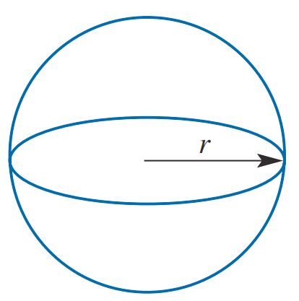  Surface area:  Volume: | 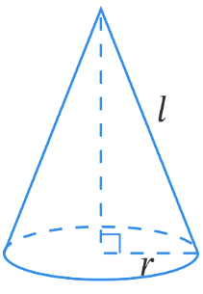  Surface area:  Volume: | 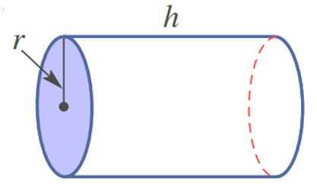  Surface area:  Volume:
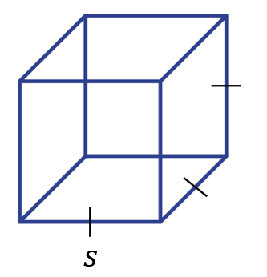  Surface area:  Volume: | - Any prism  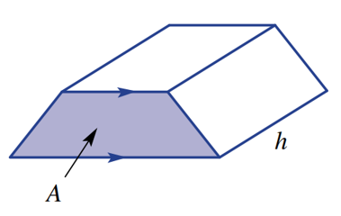  Volume: | - Any pyramid  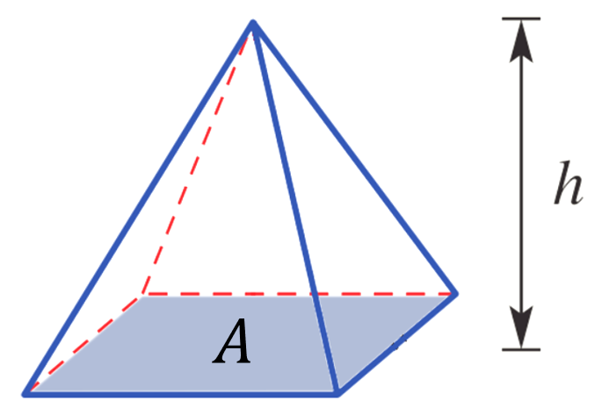  Volume:

- Interpret related rates of change problems.
For each scenario, identify the variables involved, the given variable, the rate given, and the rate you need to find. Use the units to help you identify the rates.
- A spherical ball is being heated so that its radius is increasing at a rate of 10 cm/minute.
At what rate will its volume be increasing when the radius is 20 cm?

Variables: ……, ……, …… Given variable: ………
Given rate: ……… Rate to find: ………

- A balloon is being inflated so that its radius increases at 3 cm/second.
At what rate is the surface area increasing when the radius is 12 cm?

Variables: ……, ……, …… Given variable: ………
Given rate: ……… Rate to find: ………

- A cube of ice is melting so that each edge decreases at 2 mm/hour.
How fast is the volume decreasing when each edge is 8 cm?

Variables: ……, ……, …… Given variable: ………
Given rate: ……… Rate to find: ………

- A stone is dropped into a calm pond, creating circular ripples that expand outward.
The radius of the outermost ripple increases at 6 m/second.
At what rate is the area enclosed by this ripple increasing when the radius is 10 meters?

Variables: ……, ……, …… Given variable: ………
Given rate: ……… Rate to find: ………

- A wood lathe is being used to shave down the radius of a cylindrical piece of wood.
It is 500 mm long. The radius is decreasing at a rate of 3 mm/min.
Find the rate of change of the volume when the radius is 30 mm.

Variables: ……, ……, …… Given variable: ………
Given rate: ……… Rate to find: ………

- Sand is being poured onto the top of a conical pile at the rate of 3 m³/min.
The pile always makes an angle of $45°$ with the ground
(meaning the height is equal to the radius).
Find the rate at which the height is changing when the height is 2 metres.

Variables: ……, ……, …… Given variable: ………
Given rate: ……… Rate to find: ………

- Identify formula that connects two variables and differentiate.
For each scenario, determine a formula that connects the two variables and differentiate.
- A spherical ball is being heated so that its radius is increasing.
Find the rate relating volume and radius and differentiate.

$V\left(r\right)=$ $\frac{dV}{dr}=$

- A balloon is being inflated so that its radius is increasing.
Find the rate relating surface area and radius and differentiate.

$A\left(r\right)=$ $\frac{dA}{dr}=$

- A cube of ice is melting so that each side length is decreasing.
Find the rate relating volume and side length.

$V\left(s\right)=$ $\frac{dV}{ds}=$

- A stone is dropped into a calm pond, creating circular ripples that expand outward.
Find the rate relating area of the ripple and radius.

$A\left(r\right)=$ $\frac{dA}{dr}=$

- A wood lathe is being used to shave down the radius of a cylindrical piece of wood.
The wood is 500 mm long.
Find the rate relating volume and radius.

$V\left(r\right)=$ $\frac{dV}{dr}=$

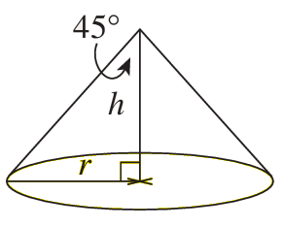
- Sand is being poured onto the top of a conical pile.
The pile always makes an angle of $45°$ with the ground
(meaning the height is equal to the radius).
Find the rate relating volume and height.

$V\left(h\right)=$ $\frac{dV}{dh}=$

- Related Rates of Change Problems
- Identify the variables, what you are given, and what you need.
- Determine formula that connects your two main variables (not time).
- Set up chain rule.
- Differentiate and substitute given rate.
- Evaluate at given variable value.

- Example Solve related rates of change problems.
A spherical ball is being heated so that its radius is increasing at a rate of 0.5 mm/s.
At what rate will its volume be increasing when the radius is 3 mm?
1. Identify variables & rates. Variables: $V, r, t$.
Given: $\frac{dr}{dt}$ $=0.5$ mm/s
$r=3$ mm
Need: $\frac{dV}{dt}$
2. Determine formula $V\left(r\right)=$ $\frac{4}{3}$ $πr^{3}$
3. Chain rule $\frac{dV}{dt}=\frac{dV}{dr}×\frac{dr}{dt}$
4. Differentiate & substitute $\frac{dV}{dt}$ $=4πr^{2}×0.5$
$$=2πr^{2}$$
5. Evaluate $\frac{dV}{dt}$ $=2π{\left(3\right)}^{2}$
$=18π$ mm³/s

- Practice
A sphere is expanding so that its radius is increasing at a rate of 2 mm/s.
At what rate will its surface area be increasing when the radius is 50 mm?

800π mm²/s
- Example Solve related ROC problems involving inverse relationships.
Water is flowing into a spherical balloon of radius $r$ and volume $V$.
The flow rate is constant at 5 cm³/s.
At what rate is the radius increasing when the volume is 36$π$ cm³? Answer to 3 s.f.
$$\frac{dr}{dt}=\frac{dr}{dV}×\frac{dV}{dt}$$  we need to find $\frac{dr}{dv}→$  $$\frac{dr}{dt}=\frac{1}{4πr^{2}}×5$$  $$=\frac{5}{4πr^{2}}$$  we need to find $r$ $→$  $\frac{dr}{dt}=\frac{5}{4π{(3)}^{2}}$  $≈0.0442$ cm/s | $V\left(r\right)=$ $\frac{4}{3}$ $πr^{3}$  $\frac{dV}{dr}$ $=4πr^{2}$  $∴$ $\frac{dr}{dV}=\frac{1}{4πr^{2}}$  $$36π=\frac{4}{3}πr^{3}$$  $$27= r^{3}$$  $∴r=3$ cm

- Practice
A chemical spill creates a circular contaminated area that expands outward.
The contaminated area is increasing at a rate of $2$ km²/hr.
At what rate is the radius of the contaminated circle increasing when the area is 9$π$ km²?

$\frac{1}{3π}$ km/h

Foundation
- The side length $x$ of a square increases at a constant rate of 2 units per second.
  - Write down an expression for the area $A$ of the square.
$$A = x²$$
  - Find $\frac{dA}{dt}$ in terms of $x$.

$$\frac{dA}{dt}= \left(\frac{dA}{dx}\right)\left(\frac{dx}{dt}\right)= 2x\left(2\right)= 4x$$
  - Hence, find the rate that the area is increasing when $x = 5$.

When x = 5: $\frac{dA}{dt}$ = 4(5) = 20 units²/s
- The side length $x$ of a cube increases at a constant rate of 3 units per second.
Find the rate of change of the following when $x = 2$.
  - Surface area.
Surface area $S = 6x²$
$$\frac{dS}{dx}= 12x$$
$$\frac{dS}{dt}= 12x\left(3\right)= 36x$$
$$When x = 2:\frac{dS}{dt}= 36\left(2\right)= 72 units²/s$$
  - Volume.
Volume $V = x³$
$$\frac{dV}{dx}= 3x^{2}$$
$$\frac{dV}{dt}= 3x^{2}\left(3\right)= 9x^{2}$$
$$When x = 2:\frac{dV}{dt}= 9{\left(2\right)}^{2}= 36 units³/s$$
- A square metal sheet is being heated such that its length is expanding at a uniform rate of 0.05 cm/s. Find the rate of change of its area at the instant when the length is 4 cm.

$$A = x^{2},\frac{dx}{dt}= 0.05$$
$$\frac{dA}{dt}= 2x\left(\frac{dx}{dt}\right)= 2x\left(0.05\right)= 0.1x$$
$$When x = 4:\frac{dA}{dt} = 0.1\left(4\right)= 0.4 cm²/s$$
- A circular plate of radius r is heated so that the area of the plate is increasing at a rate of 3 cm²/min. At what rate is the radius increasing when $r$ = 5 cm?
$$A = πr^{2},\frac{dA}{dt}= 3$$
$$\frac{dA}{dt}= 2πr\left(\frac{dr}{dt}\right)= 3$$
$$\frac{dr}{dt}=\frac{3}{2πr}$$
$$When r = 5:\frac{dr}{dt}=\frac{3}{10π} cm/min$$
- A spherical balloon is being inflated by a pump at a constant rate of $8π$ cm³/min.
  - Find an expression in terms of $r$ for the rate at which the radius of the balloon changes.

$$\frac{dV}{dt}= 4πr^{2}\left(\frac{dr}{dt}\right)= 8π$$
$$\frac{dr}{dt}=\frac{2}{r^{2}}$$
  - Find the rate at which the radius of the balloon is changing when the radius is 4 cm.

$$When r = 4:\frac{dr}{dt}=\frac{2}{16}=\frac{1}{8} cm/min$$
  - Find the rate at which the radius of the balloon is changing when the volume is $36π$ cm³.
$$When V = 36π: \left(\frac{4}{3}\right)πr^{3}= 36π$$
$$r^{3}= 27, so r = 3$$
$$\frac{dr}{dt}=\frac{2}{9} cm/min$$
- A spherical snowball is melting in such a way that its radius is decreasing at a rate of 0.5 cm/min. At what rate is the volume of the snowball decreasing when the radius is 3 cm?
Give your answer in exact form.

$$V = \left(\frac{4}{3}\right)πr^{3},\frac{dr}{dt}= -0.5$$
$$\frac{dV}{dt}= 4πr^{2}\left(-0.5\right)= -2πr^{2}$$
$$When r = 3:\frac{dV}{dt}= -2π\left(9\right)= -18π cm³/min$$
- The radius of the base of a cylinder is increasing at a rate of 6 cm/min.
The height of the cylinder is fixed at 20 cm.
Find the rate of change of the volume of the cylinder at the instant when the radius is 15 cm.

$$V = πr^{2}h = 20πr^{2},\frac{dr}{dt}= 6$$
$$\frac{dV}{dt}= 40πr\left(\frac{dr}{dt}\right)= 40πr\left(6\right)= 240πr$$
$$When r = 15:\frac{dV}{dt}= 240π\left(15\right)= 3600π cm³/min$$
- The height of a cone is 12 cm and remains constant whilst the radius of the base is increasing at a rate of 6 cm/s. At what rate is the volume of the cone increasing at the instant when the radius is 10 cm?

$$V = \left(\frac{1}{3}\right)πr^{2}h = 4πr^{2},\frac{dr}{dt}= 6$$
$$\frac{dV}{dt}= 8πr\left(\frac{dr}{dt}\right)= 8πr\left(6\right)= 48πr$$
$$When r = 10:\frac{dV}{dt}= 48π\left(10\right)= 480π cm³/s$$

Development
- A circular oil stain of radius $r$ and area $A$ is spreading on water.
  - Differentiate the area formula with respect to time to show that $\frac{dA}{dt}$ = $2πr\left(\frac{dr}{dt}\right).$
$$A = πr^{2},\frac{dA}{dt}= 2πr\left(\frac{dr}{dt}\right)$$
Hence find:
  - the rate of increase of area when $r$ = 40 cm if the radius is increasing at 3 cm/s,
$$When r = 40,\frac{dr}{dt}= 3$$
$$\frac{dA}{dt}= 2π\left(40\right)\left(3\right)= 240π cm²/s$$
  - the rate of increase of the radius when $r$ = 60 cm if the area is increasing at 10 cm²/s.
$$When r = 60,\frac{dA}{dt}= 10$$
$$10 = 2π\left(60\right)\left(\frac{dr}{dt}\right)$$
$$\frac{dr}{dt}=\frac{1}{12π} cm/s$$
- A spherical bubble of radius r is shrinking so that its volume $V$ is decreasing at a constant rate of 200cm³/s.
  - Show that $\frac{dV}{dt}= 4πr^{2}\left(\frac{dr}{dt}\right).$
$$V = \left(\frac{4}{3}\right)πr^{3},\frac{dV}{dt}= 4πr^{2}\left(\frac{dr}{dt}\right)$$
  - At what rate is its radius decreasing when the radius is $5$ cm?
$$When r = 5:$$
$$-200 = 4π\left(25\right)\left(\frac{dr}{dt}\right),$$
$$so\frac{dr}{dt}= -\frac{200}{100π}= -\frac{2}{π} cm/s$$
  - What is the radius when the radius is decreasing at $2π$ cm/s?
$$When \frac{dr}{dt}= -2π:$$
$$-200 = 4πr^{2}\left(-2π\right),$$
$$so r^{2}=\frac{25}{π^{2}}, r =\frac{5}{π} cm$$
  - At what rate is the radius decreasing when the volume is $36π$ cm³?
(Hint: First find the radius when the volume is $36π$cm³.)

$$When V = 36π: \left(\frac{4}{3}\right)πr^{3}= 36π, so r^{3}= 27, r = 3$$
$$\frac{dr}{dt}= -\frac{200}{4π\left(9\right)}= -\frac{50}{9π} cm/s$$
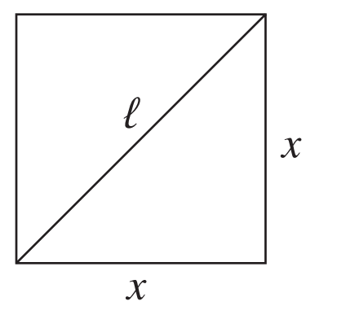
- The side length $x$ of a square shadow is increasing at 6 cm/s.
If the area is $A$ and the length of the diagonal is $l$,
  - show that $\frac{dA}{dt}= 2x\left(\frac{dx}{dt}\right)$ and $\frac{dl}{dt} = \sqrt{2}\left(\frac{dx}{dt}\right).$
$$A = x^{2},\frac{dA}{dt} = 2x\left(\frac{dx}{dt}\right)$$
$$l = x\sqrt{2},\frac{dl}{dt}= \sqrt{2}\left(\frac{dx}{dt}\right)$$
Hence find the rates of increase of the area and the diagonal when:
  - the side length is 70 cm,
$$When x = 70:\frac{dA}{dt}= 2\left(70\right)\left(6\right)= 840 cm^{2}/s,$$
$$\frac{dl}{dt} = \sqrt{2}\left(6\right) = 6\sqrt{2} cm/s$$
  - the area is 1 m².
$$When A = 1 m^{2}= 10000 cm^{2}: x = 100 cm$$
$$\frac{dA}{dt}= 2\left(100\right)\left(6\right)= 1200 cm²/s$$
$$\frac{dl}{dt}= 6\sqrt{2} cm/s$$
- A cubic block of ice is melting so that the block remains cubic.
  - If the edge is melting at 2 cm/min, find the rate at which the volume is melting when the edge is 12 cm.

$$V=x^{3}, \frac{dx}{dt}= -2,$$
$$\frac{dV}{dt}= 3x^{2}\left(\frac{dx}{dt}\right)= 3x^{2}\left(-2\right)= -6x^{2}$$
$$When x = 12:\frac{dV}{dt}= -6\left(144\right)= -864 cm³/min$$
  - If the volume is melting at 75 cm³/min, find the rate at which the edges are melting when the volume is 64 cm³.

$$\frac{dV}{dt}= -75, when V = 64: x^{3}= 64, so x = 4$$
$$-75 = 3\left(16\right)\left(\frac{dx}{dt}\right)$$
$$\frac{dx}{dt}= -\frac{75}{48}= -\frac{25}{16} cm/min$$
- The radius of a sphere is increasing at a constant rate of $k$ cm/s.
If the radius is $R$ cm, find the rate of increase of the following, in terms of $π$.
  - Surface area.
$$S = 4πr^{2},\frac{dS}{dt}= 8πr\left(\frac{dr}{dt}\right)= 8πrk$$
$$When r = R:\frac{dS}{dt}= 8πRk cm²/s$$
  - Volume.
$$V = \left(\frac{4}{3}\right)πr^{3},\frac{dV}{dt}= 4πr^{2}\left(\frac{dr}{dt}\right)= 4πr^{2}k$$
$$When r = R:\frac{dV}{dt}= 4πR^{2}k cm³/s$$
- Gas escapes a spherical bubble so that the bubble always remains a sphere.
  - Find the rate of decrease of the radius when the radius is 5 mm if the volume of the sphere is decreasing at a constant rate of 75 mm³ per sec.
$$V = \left(\frac{4}{3}\right)πr^{3},\frac{dV}{dt}= -75$$
$$4πr^{2}\left(\frac{dr}{dt}\right)= -75$$
$$When r = 5:\frac{dr}{dt} = -\frac{75}{4π\left(25\right)} = -\frac{3}{4π} mm/s$$
  - Find the rate of decrease of the radius when the radius is 12 mm if the surface area of the sphere is decreasing at 24 mm² per sec.
$$S = 4πr^{2},\frac{dS}{dt}= -24$$
$$8πr\left(\frac{dr}{dt}\right)= -24$$
$$When r = 12:\frac{dr}{dt}= -\frac{24}{96π}= -\frac{1}{4π} mm/s$$
  - Find the rate of decrease of the volume when the radius is 12 mm if the surface area of the sphere is decreasing at 24 mm² per sec.
$$From part \left(b\right):\frac{dr}{dt}= -\frac{1}{4π}$$
$$\frac{dV}{dt}= 4πr^{2}\left(\frac{dr}{dt}\right)= 4π\left(144\right)\left(-\frac{1}{4π}\right) = -144 mm³/s$$

- A lathe is used to shave down the radius of a cylindrical piece of wood 500 mm long.
The radius is decreasing at a rate of 3 mm/min.
  - Show that the rate of change of volume is $\frac{dV}{dt}$ = $-3000πr$, and find how fast the volume is decreasing when the radius is 30mm.
$$\frac{dV}{dt}= 1000πr\left(\frac{dr}{dt}\right)= 1000πr\left(-3\right)= -3000πr$$
$$When r = 30:\frac{dV}{dt}= -3000π\left(30\right) = -90000π mm³/min$$
  - How fast is the circumference decreasing when the radius is:
    - 20 mm,
$$C = 2πr,\frac{dC}{dt}= 2π\left(\frac{dr}{dt}\right)= 2π\left(-3\right)= -6π mm/min$$
    - 37 mm?
The rate is constant at $6π$ mm/min.

Mastery
- The side length $x$ of a shrinking cube is decreasing at a constant rate of 5 mm per minute.
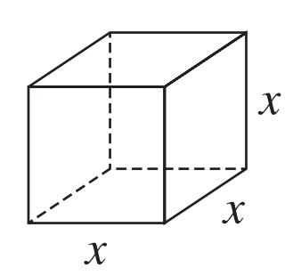
  - Show that the rates of change of volume $V$, surface area $A$, and the total edge length ℓ are
$$\frac{dV}{dt}= 3x^{2}\left(\frac{dx}{dt}\right) and \frac{dA}{dt}= 12x\left(\frac{dx}{dt}\right) and \frac{dl}{dt}= 12\left(\frac{dx}{dt}\right)$$
$$V = x^{3},\frac{dV}{dt}= 3x^{2}\left(\frac{dx}{dt}\right)$$
$$A = 6x^{2},\frac{dA}{dt}= 12x\left(\frac{dx}{dt}\right)$$
$$l = 12x,\frac{dl}{dt}= 12\left(\frac{dx}{dt}\right)$$
  - Find the rate at which volume, surface area and edge length are decreasing when:
    - i the side length is 30 cm,
$$\frac{dV}{dt}= 3\left(900\right)\left(-0.5\right)= -1350 cm³/min$$
$$\frac{dA}{dt}= 12\left(30\right)\left(-0.5\right)= -180 mm²/min,$$
$$\frac{dl}{dt}= 12\left(-0.5\right)= -6 cm/min$$
    - ii the volume is 8000 cm³.
$$When V = 8000: x³ = 8000, so x = 20$$
$$\frac{dV}{dt}= 3\left(400\right)\left(-0.5\right)= -600 cm³/min$$
$$\frac{dA}{dt}= 12\left(20\right)\left(-0.5\right)= -120 cm²/min,$$
$$\frac{dl}{dt}= -6 cm/min$$
  - Find the side length when the volume is decreasing at 300 cm³/min.
$$When\frac{dV}{dt} = -300: -300 = 3x²(-0.5) = -1.5x²$$
$$x^{2}= 200, so x = 10\sqrt{2} cm$$
- A spherical balloon is to be filled with water so that its surface area increases at a constant rate of 1 cm²/s.
  - Find, when the radius is 3 cm:
    - the required rate of increase of the radius,
$$8πr\left(\frac{dr}{dt}\right)= 1, so\frac{dr}{dt}=\frac{1}{8πr}$$
$$When r = 3:\frac{dr}{dt}=\frac{1}{24π} cm/s$$
    - the rate at which the water is flowing in at that time.
$$V = \left(\frac{4}{3}\right)πr^{3},\frac{dV}{dt}= 4πr^{2}\left(\frac{dr}{dt}\right)= 4πr^{2}×\frac{1}{8πr} =\frac{r}{2}$$
$$When r = 3:\frac{dV}{dt}=\frac{3}{2} cm³/s$$
  - Find the volume when the volume is increasing at 10 cm³/s.
$$When\frac{dV}{dt}= 10: 4πr^{2}\left(\frac{dr}{dt}\right)= 10$$
$$Also\frac{dr}{dt}=\frac{1}{8πr}, so 4πr^{2}×\frac{1}{8πr}= 10$$
$$\frac{r}{2}= 10, so r = 20 cm$$
$$V = \left(\frac{4}{3}\right)π{\left(20\right)}^{3}=\frac{32000π}{3} cm³$$
- 2020 HSC Extension 1 Band 4
The quantities P, Q and R are connected by the related rates:
$$\frac{dR}{dt}= -k^{2} \\ \frac{dP}{dt}= -l^{2}×\frac{dR}{dt} \\ \frac{dP}{dt}= m^{2}×\frac{dQ}{dt}$$
where $k$, $l$ and $m$ are non-zero constants.
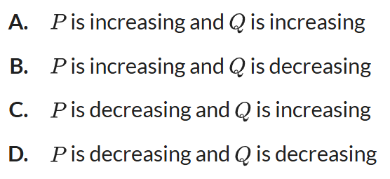
Which of the following statements is true?

$$Given:\frac{dR}{dt}= -k² < 0 (since k² > 0)$$
$$\frac{dP}{dt} = -l^{2}×\frac{dR}{dt} = -l² × (-k²) = l²k² > 0$$
$$\frac{dP}{dt} = m^{2}×\frac{dQ}{dt}, so\frac{dQ}{dt} =\frac{\frac{dP}{dt}}{m^{2}} =\frac{l^{2}k^{2}}{m^{2}} > 0$$
$$Therefore P is increasing and Q is increasing.$$
$$A$$

- 2021 HSC Extension 1 Band 4
A spherical bubble is moving up through a liquid. As it rises, the bubble gets bigger and its radius increases at the rate of 0.2 mm/s.
At what rate is the volume of the bubble increasing when its radius reaches 0.6 mm?
Express your answer in mm³/s rounded to one decimal place.
$$V = \left(\frac{4}{3}\right)πr^{3},\frac{dr}{dt} = 0.2$$
$$\frac{dV}{dt}= 4πr^{2}\left(\frac{dr}{dt}\right) = 4πr²(0.2) = 0.8πr²$$
$$When r = 0.6:\frac{dV}{dt}= 0.8π{\left(0.6\right)}^{2}= 0.8π\left(0.36\right) = 0.288π$$
$$\frac{dV}{dt} = 0.9 mm³/s$$

Further Related Rates of Change Problems

- Review
- Write an equation relating sides of a right-angled triangle.
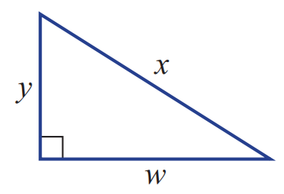 | 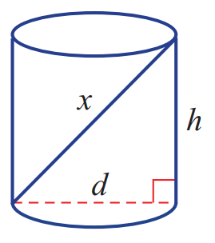

- Write an equation relating sides and angles of a right-angled triangle.
- Write an expression for $x$  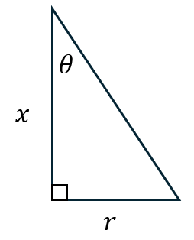 | - Write an expression for $x$  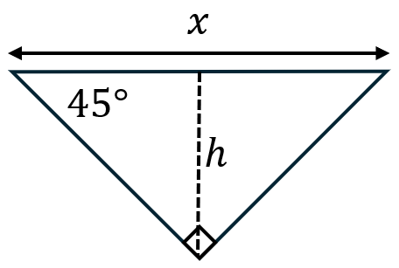

- Write an equation relating the sides of similar triangles.
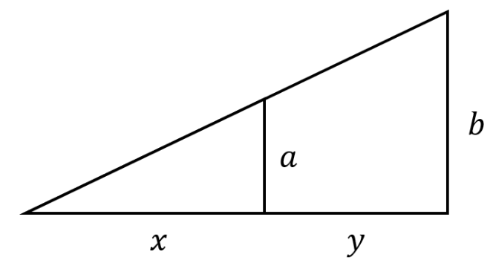 | 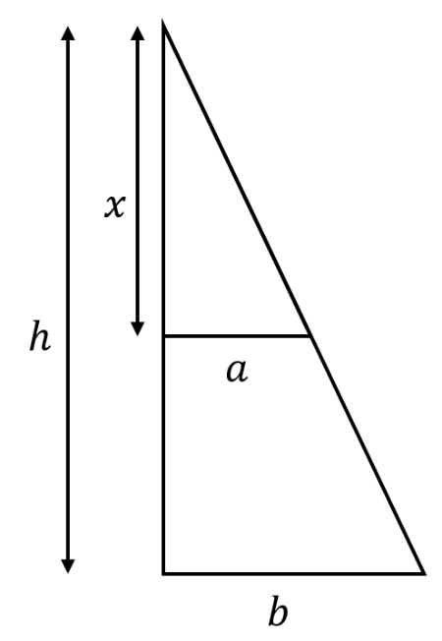

- Example Solve related ROC problems involving complex modelling.
A person walks away from a streetlight at 2 m/second.
If the streetlight is 20 m tall and the person is 2 m tall, how fast is their shadow lengthening?
Let $s$ be length of shadow, $x$ be distance from streetlight.
$$\frac{ds}{dt}=\frac{ds}{dx}×\frac{dx}{dt}$$  we need to find $\frac{ds}{dx}→$  $$\frac{ds}{dt}=\frac{1}{9}×2$$  $=$ $\frac{2}{9}$ m/s | 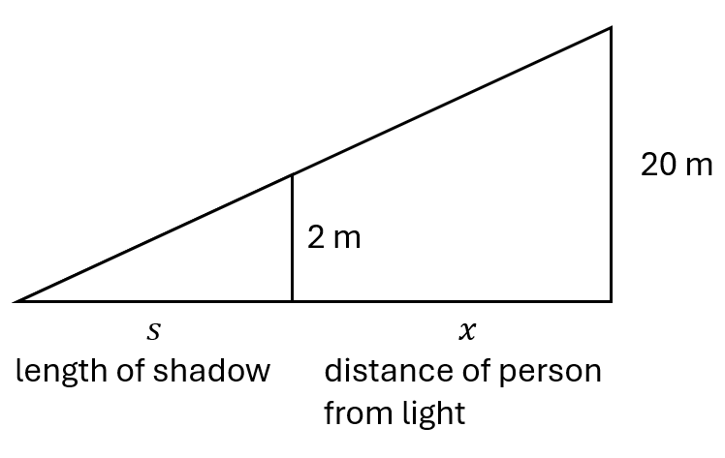  Using similar triangles  $\frac{s}{s+x}$ $=$ $\frac{2}{20}$  $$20s=2s+2x$$  $$18s=2x$$  $$s=\frac{x}{9}$$  $$∴\frac{ds}{dx}=\frac{1}{9}$$

- Practice
Car A is north of an intersection and travelling towards it, while car B is moving away from the intersection eastwards at a constant speed of 60 km h^{–1}.
The distance between the cars at any one time is 10 km.
Find the rate at which car A will be moving when car B is 8 km from the intersection.
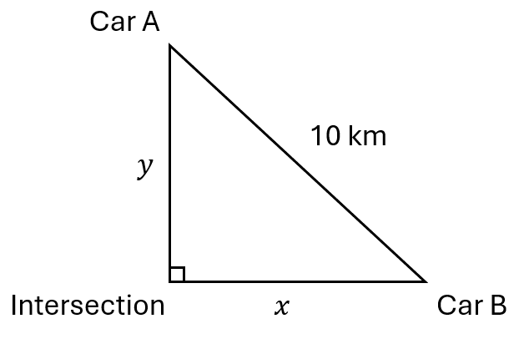
Let $y$ be distance of car A from the intersection, $x$ be distance of car B from intersection.

80 km/h

Development
- A streetlight is on top of a 8 metre pole. A child 1.2 m tall walks away from the pole at 1 m/s.
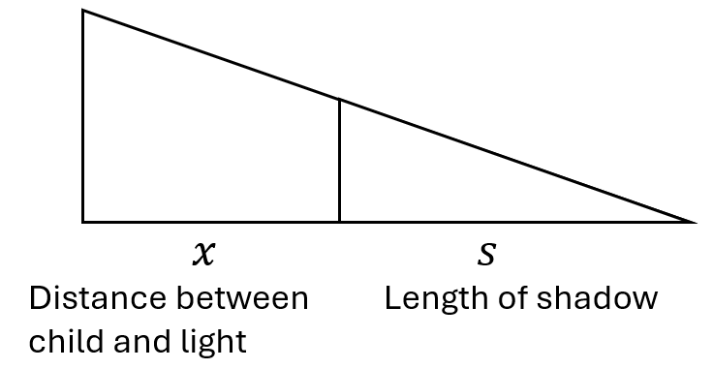
Find the rate at which the length of the shadow is changing.

$$\frac{ds}{dt}=\left(\frac{ds}{dx}\right)\left(\frac{dx}{dt}\right)$$
$$using similar triangles,\frac{s}{s+x}=\frac{1.2}{8}$$
$$s=\frac{3x}{17}$$
$$\frac{ds}{dt}=\frac{3}{17}\left(1\right)=\frac{3}{17} m/s$$

- A boy flies a kite 80 m above the ground and the wind blows it on a horizontal course at 5 m/s. Find how fast the string is being let out when the kite is 100 m from him.
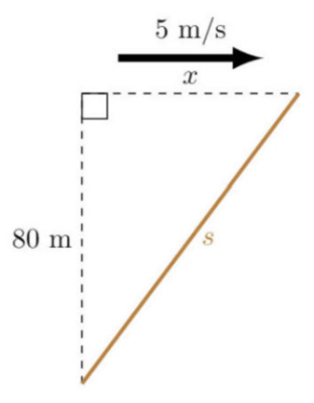

$$s^{2}= x^{2}+ {80}^{2},\frac{dx}{dt}= 5$$
$$s=\sqrt{x^{2}+{80}^{2}}$$
$$\frac{ds}{dt}=\frac{2x}{2\sqrt{x^{2}+{80}^{2}}}=\frac{x}{\sqrt{x^{2}+{80}^{2}}}$$
$$\frac{ds}{dt}=\frac{ds}{dx}×\frac{dx}{dt}=\frac{5x}{\sqrt{x^{2}+{80}^{2}}}$$
$$When s = 100: x^{2}+ 6400 = 10000, so x = 60$$
$$\frac{ds}{dt}=\frac{5\left(60\right)}{\sqrt{{60}^{2}+{80}^{2}}}= 3 m/s$$

- In this triangle ABC, ∠BAC is increasing at a constant rate of 0.2 radians/s.
Use the fact that $\frac{d}{dθ}\left(sin θ\right)= cos θ$ to find the rate of change in the area of △ABC when $θ =$ $\frac{π}{3}$ .
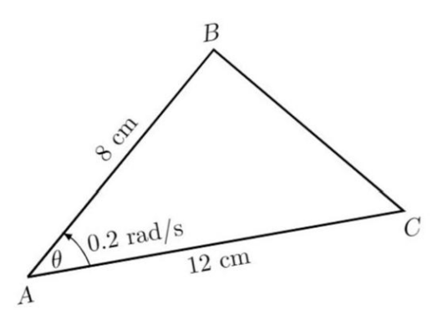

$$Area = \left(\frac{1}{2}\right)\left(AB\right)\left(AC\right)sin θ = \left(\frac{1}{2}\right)\left(8\right)\left(12\right)sin θ = 48 sin θ$$
$$\frac{dθ}{dt}= 0.2$$
$$\frac{dA}{dt}= 48 cos θ \left(\frac{dθ}{dt}\right)= 48 cos θ \left(0.2\right)= 9.6 cos θ$$
$$When θ =\frac{π}{3}:\frac{dA}{dt}= 9.6 cos\left(\frac{π}{3}\right)= 9.6\left(\frac{1}{2}\right)= 4.8 cm²/s$$

- Water is poured into an inverted right conical vessel at a constant rate of 8 cm³/sec.
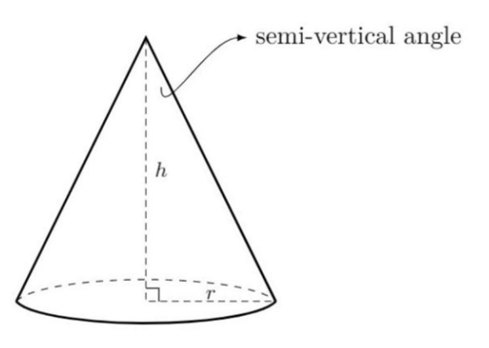
  - Find the relationship between $h$ and $r$,
given the semi vertical angle in each case below.
Hence, express the volume of the cone in terms of $h$ only.
    - Semivertical angle is 45°

$$tan 45° =\frac{r}{h}= 1, so r = h$$
$$V = \left(\frac{1}{3}\right)πr^{2}h = \left(\frac{1}{3}\right)π\left(h^{2}\right)h = \left(\frac{π}{3}\right)h^{3}$$
    - Semivertical angle is 30°

$$tan 30°=\frac{r}{h}=\frac{1}{\sqrt{3}}, so r =\frac{h}{\sqrt{3}}$$
$$V = \left(\frac{1}{3}\right)πr^{2}h = \left(\frac{1}{3}\right)π{\left(\frac{h}{\sqrt{3}}\right)}^{2}h = \left(\frac{π}{9}\right)h^{3}$$
  - Hence, find the rate the water level rises when the depth is 4 cm, given that
    - the semivertical angle is 45°

$$V = \left(\frac{π}{3}\right)h^{3}$$
$$\frac{dV}{dt}= πh^{2}\left(\frac{dh}{dt}\right)= 8$$
$$\frac{dh}{dt}=\frac{8}{πh^{2}}$$
$$When h = 4:\frac{dh}{dt}=\frac{8}{16π}=\frac{1}{2π} cm/s$$
    - the semivertical angle is 30°

$$V = \left(\frac{π}{9}\right)h^{3}$$
$$\frac{dV}{dt}= \left(\frac{π}{3}\right)h^{2}\left(\frac{dh}{dt}\right)= 8$$
$$\frac{dh}{dt}=\frac{24}{πh^{2}}$$
$$When h = 4:\frac{dh}{dt}=\frac{24}{16π}=\frac{3}{2π} cm/s$$

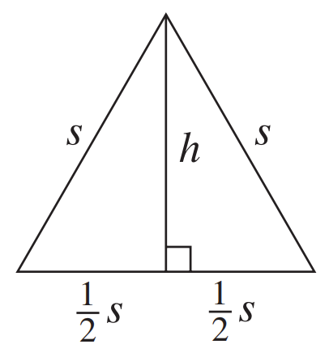
- Show that in an equilateral triangle of side length $s$,
the area is $A = \left(\frac{1}{4}\right)s^{2}\sqrt{3}$ and the height is $h = \left(\frac{1}{2}\right)s\sqrt{3}$.
  - Find formulae for the rates of change of area and
height in terms of the rate of change of side length.

$$\frac{dA}{dt} = \left(\frac{1}{2}\right)s\sqrt{3}\left(\frac{ds}{dt}\right)$$
$$\frac{dh}{dt} = \left(\frac{1}{2}\right)\sqrt{3}\left(\frac{ds}{dt}\right)$$
  - Hence find the rate at which the area and the height are increasing when the side length is 12cm and is increasing at 3mm/s.
$$When s = 12 cm = 120 mm,\frac{ds}{dt}= 3:$$
$$\frac{dA}{dt}= \left(\frac{1}{2}\right)\left(120\right)\sqrt{3}\left(3\right)= 180\sqrt{3} mm²/s$$
$$\frac{dh}{dt}= \left(\frac{1}{2}\right)\sqrt{3\left(3\right)}=\frac{3\sqrt{3}}{2} mm/s$$
- Sand being poured from a conveyor belt forms a cone with height h and semi-vertical angle 60°.
  - Show that the volume of the pile is $V = πh³$, and differentiate with respect to $t$.
$$tan 60° =\frac{r}{h}= \sqrt{3}, so r = h\sqrt{3}$$
$$V = \left(\frac{1}{3}\right)πr^{2}h = \left(\frac{1}{3}\right)π\left(3h^{2}\right)h = πh^{3}$$
$$\frac{dV}{dt}= 3πh^{2}\left(\frac{dh}{dt}\right)$$
  - Suppose that the sand is being poured at a constant rate of 0.3 m³/min, and let $A$ be the area of the base. Find the rate at which the height is increasing:
    - when the height is 4 metres,
$$When h = 4: 0.3 = 3π\left(16\right)\left(\frac{dh}{dt}\right),$$
$$so\frac{dh}{dt}=\frac{0.3}{48π}=\frac{1}{160π} m/min$$
    - when the radius is 4 metres.
$$When r = 4: h =\frac{4}{\sqrt{3}}, so 0.3 = 3π\left(\frac{16}{3}\right)\left(\frac{dh}{dt}\right)$$
$$\frac{dh}{dt}=\frac{0.3}{16π}=\frac{3}{160π} m/min$$
  - Show that $\frac{dA}{dt}= 6πh\left(\frac{dh}{dt}\right),$ and find the rate of increase of the base area at these times.
$$A = πr^{2}= 3πh^{2},\frac{dA}{dt}= 6πh\left(\frac{dh}{dt}\right)$$
$$\frac{dA}{dt}= 6π\left(4\right)×\frac{1}{160π}=\frac{3}{20} m²/min$$
$$\frac{dA}{dt}= 6π\left(\frac{4}{\sqrt{3}}\right)×\frac{3}{160π}=\frac{9\sqrt{3}}{20} m²/min$$
  - At what rate must the sand be poured if it is required that the height increase at 8cm/min, when the height is 4 metres?
$$When h = 4,\frac{dh}{dt}= 8 cm/min= 0.08 m/min$$
$$\frac{dV}{dt}= 3π\left(16\right)\left(0.08\right)= 3.84π m³/min$$

Mastery
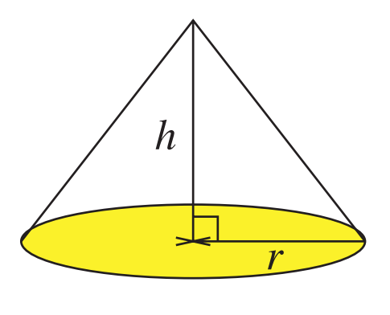
- Sand is poured at a rate of 0.5 m³/s onto the top of a pile in the shape of a cone, as shown in the diagram. Let the base have radius r, and let the height of the cone be h. The pile always remains in the same shape, with $r = 2h$.
  - Find the cone's volume in terms of $h$,
and show that it is the same as the volume of a sphere
whose radius is equal to the cone's height.

$$r = 2h, so V = \left(\frac{1}{3}\right)πr^{2}h = \left(\frac{1}{3}\right)π\left(4h^{2}\right)h = \left(\frac{4π}{3}\right)h^{3}$$
$$Sphere volume with radius h: V = \left(\frac{4π}{3}\right)h^{3}$$

  - Find the rate at which the height is increasing when the radius of the base is 4 metres.
$$\frac{dV}{dt}= 4πh^{2}\left(\frac{dh}{dt}\right)= 0.5$$
$$When r = 4: h = 2, so 0.5 = 4π\left(4\right)\left(\frac{dh}{dt}\right)$$
$$\frac{dh}{dt}=\frac{0.5}{16π}=\frac{1}{32π} m/s$$

- HSC Extension 1 Sample Question Band 4
The diagram shows an equilateral triangle with side length x cm and area A cm².
The area of the triangle is increasing at a rate of 6 cm² per second.
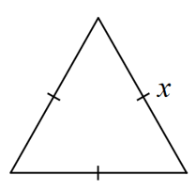
Find the rate at which the side length $x$ is expanding when the triangle has side length of 4 cm.
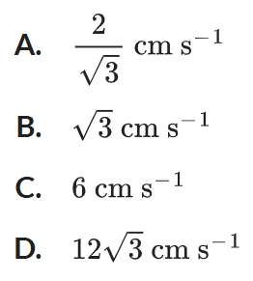

$$For equilateral triangle: A = \left(\frac{\sqrt{3}}{4}\right)x²$$
$$dA/dt = \left(\frac{\sqrt{3}}{2}\right)x\left(\frac{dx}{dt}\right) = 6$$
$$When x = 4: 6 = \left(\frac{\sqrt{3}}{2}\right)\left(4\right)\left(\frac{dx}{dt}\right)$$
$$6 = 2\sqrt{3}\left(\frac{dx}{dt}\right)$$
$$\frac{dx}{dt}=\frac{6}{2\sqrt{3}}=\frac{3}{\sqrt{3}}= \sqrt{3} cm/s$$
$$∴B$$

- HSC Extension 1 Sample Question Band 4
A wheat silo in the shape of a right cone is pictured below.
The silo has a height of 12 metres and a base radius of 5 metres. Wheat is poured into the top of the silo at a rate of 3 cubic metres per minute.
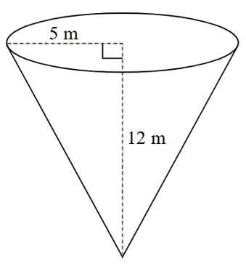
At any given time, the wheat filling the silo will have a vertical height of h metres from the bottom tip and a radius r.

  - Explain why $r =\frac{5h}{12}$.
  - Find an expression for $\frac{dh}{dt}$.
  - At what rate is the height of the wheat in the cone increasing when the height of the wheat in the cone is 7 metres from the bottom?

$$a) Using similar triangles:\frac{r}{h}=\frac{5}{12}, so r =\frac{5h}{12}$$
$$b) V = \left(\frac{1}{3}\right)πr^{2}h = \left(\frac{1}{3}\right)π{\left(\frac{5h}{12}\right)}^{2}h = \left(\frac{1}{3}\right)π\left(\frac{25h^{2}}{144}\right)h = \left(\frac{25π}{432}\right)h^{3}$$
$$\frac{dV}{dt}= \left(\frac{25π}{144}\right)h^{2}\left(\frac{dh}{dt}\right)= 3$$
$$Therefore:\frac{dh}{dt}= 3 ×\frac{144}{25πh^{2}}=\frac{432}{25πh^{2}}$$
$$c) When h = 7:\frac{dh}{dt}=\frac{432}{25π\left(49\right)}=\frac{432}{1225π} m/min$$

- An upturned cone of semi-vertical angle 45° is being filled with water at a constant rate of 20cm³/s. Find the rate at which the height of the water, the area of the water surface, and the area of the cone wetted by the water, are increasing when the water height is 50 cm.
$$Semivertical angle 45°: tan 45° =\frac{r}{h}= 1, so r = h$$
$$V = \left(\frac{1}{3}\right)πr^{2}h = \left(\frac{1}{3}\right)πh^{3},\frac{dV}{dt}= 20$$
$$\frac{dV}{dt}= πh^{2}\left(\frac{dh}{dt}\right)= 20, so\frac{dh}{dt}=\frac{20}{πh^{2}}$$
$$When h = 50:\frac{dh}{dt}=\frac{20}{2500π}=\frac{4}{125π} cm/s$$
$$Water surface area:A_{1}= πr^{2}= πh^{2},\frac{dA^{1}}{dt}= 2πh\left(\frac{dh}{dt}\right)= 2πh ×\frac{20}{πh^{2}}=\frac{40}{h}$$
$$When h = 50:\frac{dA^{1}}{dt}=\frac{40}{50}=\frac{4}{5} cm²/s$$
$$Wetted cone area: A₂ = πrl where l = h\sqrt{2}, so A₂ = πh^{2}\sqrt{2}$$
$$\frac{dA^{2}}{dt}= 2πh\sqrt{2\left(\frac{dh}{dt}\right)}= 2πh\sqrt{2}×\frac{20}{πh^{2}}=\frac{40\sqrt{2}}{h}$$
$$When h = 50:\frac{dA^{2}}{dt}=\frac{40\sqrt{2}}{50}=\frac{4\sqrt{2}}{5} cm²/s$$

- A square pyramid has height twice its side length $s$.
  - Show that the volume $V$ and the surface area $A$ are $V = \left(\frac{2}{3}\right)s^{3}$ and $A = \left(\sqrt{17}+ 1\right)s².$

$$V = \left(\frac{1}{3}\right) × s² × 2s = \left(\frac{2}{3}\right)s^{3}$$
$$slant height = \sqrt{{\left(\frac{s}{2}\right)}^{2}+ {\left(2s\right)}^{2}}= \sqrt{\frac{s^{2}}{4}+ 4s^{2}}=\frac{s\sqrt{17}}{2}$$
$$A = s^{2}+ 4 \left(\frac{1}{2}\right)s \frac{s\sqrt{17}}{2}= s^{2}+ s^{2}\sqrt{17}= s^{2}\left(\sqrt{17}+ 1\right)$$

  - Hence find the rate at which $V$ and $A$ are decreasing when the side length is 4 metres if the side length is shrinking at 3 mm/s.

$$\frac{ds}{dt}= -3 mm/s = -0.003 m/s, s = 4 m$$
$$\frac{dV}{dt}= 2s^{2}\left(\frac{ds}{dt}\right)= 2\left(16\right)\left(-0.003\right)= -0.096 m³/s$$
$$\frac{dA}{dt}= 2s\left(\sqrt{17}+ 1\right)\left(\frac{ds}{dt}\right) = 2\left(4\right)\left(\sqrt{17}+ 1\right)\left(-0.003\right) = -\frac{3}{125}\left(\sqrt{17}+ 1\right) m²/s$$

- A ladder 13 metres long rests against a wall, with its base $x$ metres from the wall and its top $y$ metres high.
  - Explain why $x² + y² = 169$, solve for $y$, and differentiate with respect to $t$.
$$x² + y² = 169, so y = \sqrt{169 - x^{2}}$$
$$\frac{dy}{dt}=\frac{dy}{dx}×\frac{dx}{dt}$$
$$So\frac{dy}{dt}= -\frac{x}{\sqrt{169-x^{2}}}\left(\frac{dx}{dt}\right)$$

Hence find, when the base is 5 metres from the wall:
  - the rate at which the top is slipping down when the base is slipping out at 1 cm/s,

$$When x = 5: y = \sqrt{169 - 25}= 12$$
$$\frac{dx}{dt}= 1 cm/s$$
$$\frac{dy}{dt}= -\frac{5\left(1\right)}{12}= -\frac{5}{12} cm/s$$
  - the rate at which the base is slipping out when the top is slipping down at 5 mm/s.

$$\frac{dy}{dt} = -5 mm/s$$
$$-5 = -\frac{5}{12}\left(\frac{dx}{dt}\right), so\frac{dx}{dt} = 12 mm/s$$

- The water trough in the diagram is in the shape of an isosceles right triangular prism, 3 metres long. A farmer is filling the trough with a hose at the rate of 2 litres per second.
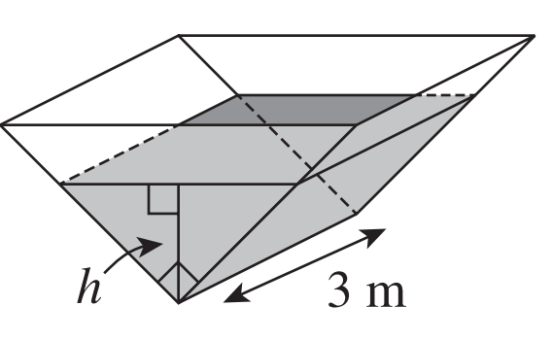
  - Show that the volume of water in the trough
when the depth is h cm is V = 300h² cm³.

$$Cross section is right isosceles triangle with legs of length h$$
Semi-vertical angle is $45°$. Let half of top length of water surface: $\tan{45°}=$ $\frac{x}{h}$
$∴x=h$ and top surface us $2x=2h$
$$Area = \left(\frac{1}{2}\right) × 2h × h = h^{2},$$
$$Volume = h² × 300 = 300h² cm³$$
  - Given that 1 litre is 1000 cm³, find the rate at which the depth of the water is changing when h = 20 cm.
$$\frac{dV}{dt} = 2 L/s = 2000 cm³/s$$
$$\frac{dV}{dt} = 600h\left(\frac{dh}{dt}\right) = 2000$$
$$When h = 20:\frac{dh}{dt} =\frac{2000}{600 × 20} =\frac{2000}{12000} =\frac{1}{6} cm/s$$
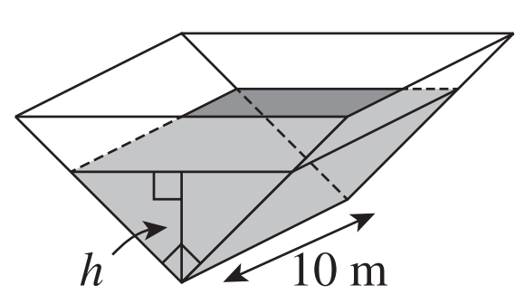
- A water trough is 10 metres long, with cross section a right isosceles triangle.
  - Show that when the water has depth $h$ cm,
its volume is $V = 1000h²$ and its surface area is $A = 2000h$.

$$Right isosceles triangle: if depth is h, width at top is 2h$$
$$Cross sectional area = \left(\frac{1}{2}\right)× 2h × h = h²$$
$$V = h² × 1000 = 1000h² cm³$$
$$Surface area = width × length = 2h × 1000 = 2000h cm²$$
  - Find the rates at which depth and surface area are increasing when the depth is 60cm if the trough is filling at 5 litres per minute (remember that 1 litre is 1000cm³).
$$\frac{dV}{dt} = 5 L/min = 5000 cm³/min$$
$$\frac{dV}{dt} = 2000h\left(\frac{dh}{dt}\right) = 5000$$
$$When h = 60:\frac{dh}{dt} =\frac{5000}{2000 × 60} =\frac{5000}{120000} =\frac{1}{24} cm/min$$
$$\frac{dA}{dt} = 2000\left(\frac{dh}{dt}\right) = 2000 ×\frac{1}{24}=\frac{250}{3} cm²/min$$
  - Find the rates at which the volume and the surface area must increase when the depth is 40cm, if the depth is required to increase at a constant rate of 0.1cm/min.
$$When h = 40,\frac{dh}{dt} = 0.1:$$
$$\frac{dV}{dt} = 2000h\left(\frac{dh}{dt}\right) = 2000(40)(0.1) = 8000 cm³/min = 8 L/min$$
$$\frac{dA}{dt}= 2000\left(\frac{dh}{dt}\right) = 2000(0.1) = 200 cm²/min$$
- 2009 HSC Extension 1 Band 6
The cross-section of a 10-metre-long tank is an isosceles triangle, as shown in the diagram.
The top of the tank is horizontal.
When the tank is full, the depth of water is 3 m. The depth of water at time $t$ days is $h$ metres.
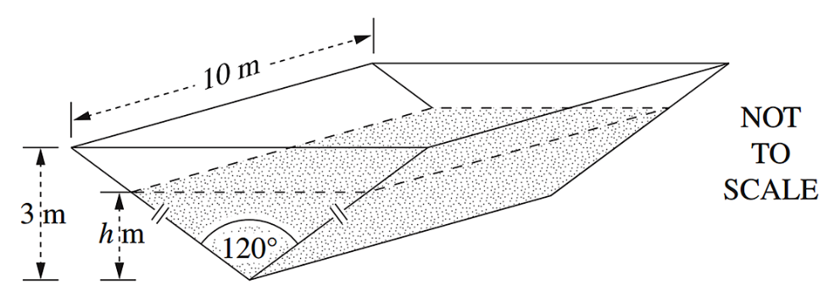

  - Find the volume, $V$, of water in the tank when the depth of water is $h$ metres.
$$Let A = area of front$$
$$tan30° =\frac{h}{x}$$
$$x =\frac{h}{tan 30°} = \sqrt{3}h$$
$$∴ A = 2 × \left(\frac{1}{2}\right)× \sqrt{3}h × h = \sqrt{3}h^{2} m²$$
$$V = Ah = \sqrt{3}h² × 10 = 10\sqrt{3}h² m³$$

  - Show that the area, $A$, of the top surface of the water is given by $A = 20\sqrt{3}h$ .

Width of top surface = $2x=2\sqrt{3}h$
$$A=10×2\sqrt{3}h=20\sqrt{3}h$$
  - The rate of evaporation of the water is given by $\frac{dV}{dt}= -kA$, where $k$ is a positive constant.
Find the rate at which the depth of water is changing at time $t$.
$$\frac{dh}{dt}=\frac{dh}{dV}×\frac{dV}{dt}$$
$$\frac{dV}{dt}= -kA= -k\left(20\sqrt{3}h\right)$$
$$V = 10\sqrt{3}h²$$
$$\frac{dV}{dh}= 20\sqrt{3}h$$
$$Finding \frac{dh}{dt}:$$
$$\frac{dh}{dt}=\frac{dh}{dV}×\frac{dV}{dt}$$
$$=\frac{1}{20\sqrt{3}h}×-k\left(20\sqrt{3}h\right)$$
$= -k$ m/day
  - It takes 100 days for the depth to fall from 3 m to 2 m.
Find the time taken for the depth to fall from 2 m to 1 m.
Since $\frac{dh}{dt}$ is constant, it will take the same number of days for the depth to fall 1 m.
$∴$ 100 days.

- 2012 HSC Extension 1 Band 6
A plane P takes off from a point B. It flies due north at a constant angle α to the horizontal.
An observer is located at A, 1 km from B, at a bearing 060° from B.
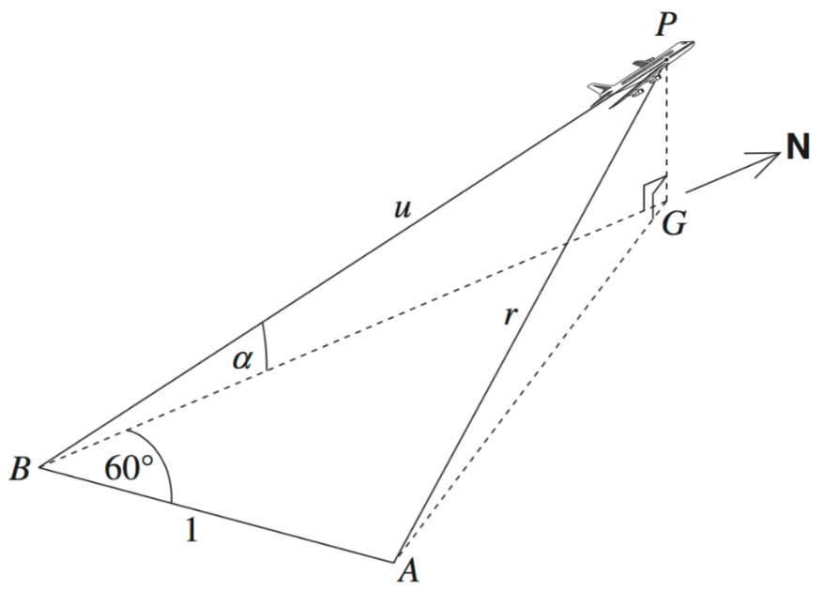
Let $u$ km be the distance from B to the plane and let $r$ km be the distance from the observer to the plane. The point $G$ is on the ground directly below the plane.

  - Show that $r = \sqrt{1 + u^{2}- u\cos{α}}.$
Using triangle PBG:
$BG = u\cos{α}$, $PG =$ $u\sin{α}$

In triangle ABG:
$$AG^{2}= 1 + u^{2}\cos^{2}{α} - 2u\cos{α}\cos{60°}$$
$$= 1 + u²cos²α - u\cos{α}$$

In triangle APG: $r² = AG² + PG²$
$r²$ = $1 + u²cos²α - u\cos{α}$ $+ u^{2}\sin^{2}{α}$
$$r^{2}= 1 + u^{2}\left(cos^{2}α + sin^{2}α\right)- u cosα$$
$$r^{2}= 1 + u^{2}- u cosα$$
$∴r = \sqrt{1 + u^{2}- u cosα}$
  - The plane is travelling at a constant speed of 360 km/h.
At what rate, in terms of $α$, is the distance of the plane from the observer changing 5 minutes after take-off?

Speed = 360 km/h, so after 5 minutes: $u = 360 × \left(\frac{5}{60}\right)$ = 30 km
$$\frac{dr}{dt}=\frac{dr}{du}×\frac{du}{dt}$$
Note that $α$ is not a variable as the angle of ascent remains constant
$$\frac{dr}{du}=\frac{2u - cosα}{2\sqrt{1 + u^{2}- ucosα}}$$
$\frac{du}{dt}$ $=$ 360 km/h
At $u$ = 30:
$$\frac{dr}{du}=\frac{60 - cosα}{2\sqrt{1 + 900 - 30cosα}}$$
$$\frac{dr}{dt}=\frac{360\left(60 - cosα\right)}{2\sqrt{901 - 30cosα}}=\frac{180\left(60 - cosα\right)}{\sqrt{901 - 30 cosα}} km/h$$

Modified Growth and Decay

- Modified Growth and Decay
In realistic models of growth and decay, the change is proportional to the difference of the current value to some constant value, $P$.
Larger difference means faster change.
initial quantity
$$t=0$$
$$If Q=P+Ae^{kt}, \frac{dQ}{dt}=kAe^{kt} \\ =k\left(P+Ae^{kt}-P\right) \\ =k\left(Q-P\right)$$

$$k<0$$  $$A>0$$ | $$k<0$$  $$A<0$$ | $$k>0$$  $$A>0$$ | $$k>0$$  $$A<0$$  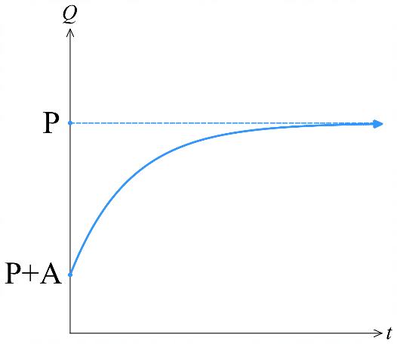  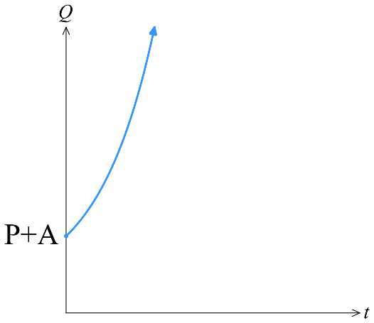  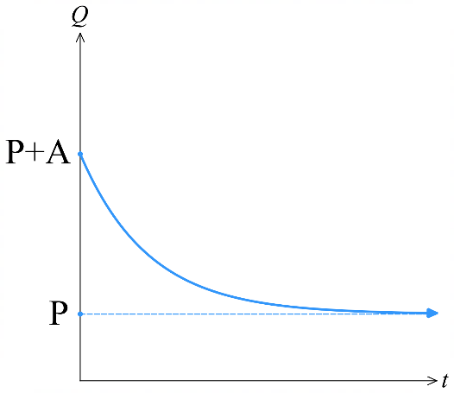  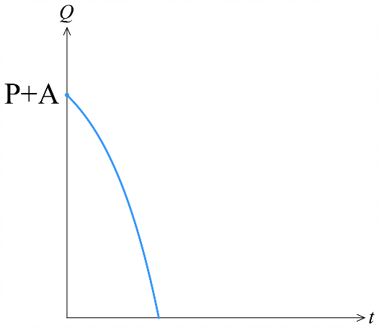
We will focus on cases where $k<0$.
When $k<0$, the quantity $Q$ approaches a limiting value $P$ as $t→∞$.
This limiting value $P$ can represent:
- ambient temperature; hot objects cool towards room temperature.
- carrying capacity; populations stabilise at the maximum an environment can support.

- Interpret modified growth and decay.
The temperature of a cup of coffee is changing according to:  $$T=20+80e^{-2t}$$  - Show that $\frac{dT}{dt}$ $=k\left(T-20\right)$  (by adding and subtracting)  - Sketch the graph of $T\left(t\right)$.  - What is the initial temperature?  - What happens as $t→∞$? | The population of monkeys on an island is changing according to:  $$P=200-150e^{-2t}$$  - Show that $\frac{dP}{dt}$ $=k(P-200)$  (by separately expanding)  - Sketch the graph of $y=P\left(t\right)$.  - What is the initial population?  - What happens as $t→∞$?

- Interpret modified growth and decay.
The following scenarios all have a limiting value;
limiting value
$$t→∞$$
They have the differential equation where $k<0$:
initial value
$$t=0$$
$$\frac{dQ}{dt}=k\left(Q-P\right); Q=P+Ae^{kt}$$

For each scenario, write an expression for $Q\left(t\right)$and draw a quick sketch of $y=Q\left(t\right)$.

- A tray of brownies is cooling.  Its initial temperature is 200°C and  room temperature is 25°C. | - A tray of brownies is in the oven.  The oven temperature is 200°C and the brownies were put in at 25°C.
- A group of penguins lives on an island.  The carrying capacity of the island is 300 penguins. The initial population is 50. | - A phone battery is charging to full.  The initial battery level is 5% and the maximum battery level is 100%.
- A cube of ice was removed from the freezer. Its initial temperature is –15°C and room temperature is 20°C. | - An air conditioner can reduce moisture levels to 30%. The current humidity is 70%.
- Finding the value of $k$.
Modified growth and decay problems usually involve finding the value of $k$.
$$if \frac{dQ}{dt}=k\left(Q-P\right), then Q=P+Ae^{kt}$$
            - Write $Q=P+Ae^{kt}$. Remember that $P$ is the limiting value and $A+P$ is the initial value.
            - Substitute in given values and solve for $k$. Leave in exact form.
            - Rewrite equation with $P,$ $A$ and $k$.
            - Solve for what the question asks for.
- In questions where you need to find the derivative or solve for $t$,
write $k$ instead of its exact value to avoid writing a complex logarithm every line.

- Example Solve modified growth and decay problems.
The ambient temperature of a kitchen is 20°C.
A kettle of boiling (100°C) water is taken off the stove.
5 minutes later, the temperature of the water is 70°C.
How long will it take for the water temperature to drop to 25°C?
1. $Q=P+Ae^{kt}$  $Q=20+Ae^{kt}$  $$Q=20+80e^{kt}$$  2. $70=20+80e^{5k}$  $50=80e^{5k}$  $0.625=e^{5k}$  $$\ln\left(0.625\right)=5k$$  $$k=\frac{\ln\left(0.625\right)}{5}$$ | 3. $Q=20+80e^{\frac{\ln\left(0.625\right)}{5}t}$  4. Solve $Q\left(t\right)=25$  $$25=20+80e^{kt}$$  $$5=80e^{kt}$$  $$0.0625=e^{kt}$$  $$\ln\left(0.0625\right)=kt$$  $$t=\frac{\ln\left(0.0625\right)}{k}$$  $$=\frac{\ln\left(0.0625\right)}{\left(\frac{\ln\left(0.625\right)}{5}\right)}≈29.5 min$$

- Practice
A pot of coffee is heated to 95°C.
The room temperature is a constant 25°C and the coffee cools down to 55°C after 5 minutes.
The cooling rate is proportional to the difference between the coffee and room temperatures.
When will the coffee reach optimal drinking temperature, 60°C?

4.09 minutes https://www.desmos.com/calculator/h4urzktg68
A sponge has a water content of 800 mL when fully saturated.
When the sponge is dried out and then placed back in water, it absorbs water at a rate proportional to how much water it still needs to reach full saturation.
A squeezed sponge has 200 mL of water.
After being placed back into the water, it has water content of 440 mL after 3 seconds.
- Find when the water content rises to 790 mL.
- Find the rate of absorption after 3 seconds.

a) 24.0 s https://www.desmos.com/calculator/ggxsqhdrtl
b) 61.3 mL/s https://www.desmos.com/calculator/nrp3zw6csc

Foundation
- A cup full of coffee initially has temperature 70°C, and it sits in a room of temperature 20°C.
The temperature of the coffee cup can be modelled by the differential equation
$\frac{dT}{dt}$ $= k\left(T-B\right),$ where $B$ is the temperature of the room and $T$ is the temperature of the coffee cup after $t$ minutes.
  - Show that $T = 20+50e^{kt}$ satisfies the differential equation.
$$T = 20 + 50e^{kt}$$
$$\frac{dT}{dt}= 50ke^{kt}$$
$$=k\left(50e^{kt}\right)$$
$$k\left(20+50e^{kt}-20\right)$$
$$=k\left(T-20\right)=k\left(T-B\right)$$

  - After ten minutes, the temperature of the coffee cup reduces to 50°C.
Find the value of $k$ in exact form.
$$When t = 10, T = 50:$$
$$50 = 20 + 50e^{10k}$$
$$30 = 50e^{10k}$$
$$e^{10k}=\frac{3}{5}$$
$$k =\frac{1}{10}ln\left(\frac{3}{5}\right)$$
  - What is the temperature of the coffee cup after five minutes?

$$T = 20 + 50e^{5k}≈ 59°C$$
  - After how many minutes, to the nearest minute, will the temperature drop below 30°C?

$$30 = 20 + 50e^{kt}$$
$$10 = 50e^{kt}$$
$$e^{kt}=\frac{1}{5}$$
$$t =\frac{ln\left(\frac{1}{5}\right)}{k}≈ 32 minutes$$
  - What is the limiting temperature of the coffee?
As $t → ∞,$ since $k < 0$, $e^{kt}→0$, so $T → 20°C$

  - Draw a graph of the temperature against time, labelling all important features.
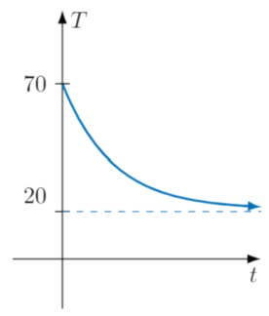

- A frozen casserole dish with initial temperature $T$ = 0°C is left in an oven set to 180°C. After ten minutes, the dish has temperature $T$ = 30°C. The rate that the temperature of the dish increases is proportional to the difference in temperature between the oven and the dish.
  - Is the growth constant $k$ positive or negative?
Negative (this is exponential decay, reflected)
  - Complete the equation $\frac{dT}{dt}$ $=$
$$\frac{dT}{dt}= k\left(180 - T\right)$$
  - Show that $T = 180\left(1 -e^{-kt}\right)$ satisfies the differential equation from b.
$$T = 180\left(1 - e^{-kt}\right)$$
$$\frac{dT}{dt}= 180ke^{-kt}$$
$$k\left(180 - T\right)= k\left(180 - 180\left(1 - e^{-kt}\right)\right)= k\left(180e^{-kt}\right)= 180ke^{-kt}$$
  - Find the value of $k$. Leave in exact form.
$$When t = 10, T = 30:$$
$$30 = 180\left(1 - e^{-10k}\right)$$
$$\frac{1}{6}= 1 - e^{-10k}$$
$$e^{-10k}=\frac{5}{6}$$
$$k = \left(\frac{1}{10}\right)ln\left(\frac{6}{5}\right)$$
  - Find the temperature of the dish after an hour.
$$T = 180\left(1 - e^{-60k}\right)$$
$$T = 180\left(1 - {\left(\frac{5}{6}\right)}^{6}\right)= 120°C$$
  - The dish is ready to serve when the interior temperature is at least 60°C.
After how many minutes, to the nearest minute, will the dish be ready?
$$60 = 180\left(1 - e^{-kt}\right)$$
$$\frac{1}{3}= 1 - e^{-kt}$$
$$e^{-kt}=\frac{2}{3}$$
$$t =\frac{10ln\left(\frac{3}{2}\right)}{ln\left(\frac{6}{5}\right)}= 23 minutes \left(at 22 minutes the interior is not yet 60°C\right)$$
  - Draw a graph of the temperature against time, labelling all important features.
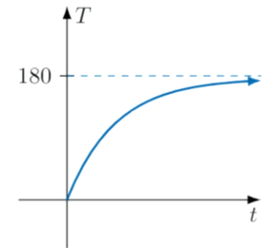

- The rate of increase of a population $P$ of green and purple flying bugs is proportional to the excess of the population over 2000, that is, $\frac{dP}{dt}$ $= k\left(P - 2000\right)$, for some constant $k$.
Initially the population is 3000, and three weeks later the population is 8000.
  - Show that $P = 2000 + Ae^{kt}$ satisfies the differential equation, where $A$ is constant.
  - By substituting $t=0$ and $t=3$, find the values of $A$ and $k$.
  - Find the population after seven weeks, correct to the nearest ten bugs.
  - Find when the population reaches 500000, correct to the nearest 0.1 weeks.
$$a) P = 2000 + Ae^{kt}$$
$$\frac{dP}{dt}= Ake^{kt}$$
$$k\left(P - 2000\right)= k\left(Ae^{kt}\right)= Ake^{kt}$$
$$b) t = 0: 3000 = 2000 + A, so A = 1000$$
$$t = 3: 8000 = 2000 + 1000e^{3k}$$
$$6000 = 1000e^{3k}$$
$$e^{3k}= 6$$
$$k = \left(\frac{1}{3}\right)log_{e}6$$
$$c) P = 2000 + 1000e^{7k}= 67420 bugs$$
$$d) 500000 = 2000 + 1000e^{kt}$$
$$498000 = 1000e^{kt}$$
$$e^{kt}= 498$$
$$t =\frac{\ln{498}}{k} = 10.4 weeks$$
- During the autumn, the rate of decrease of the fly population $F$ is proportional to the excess over 30000, that is, $\frac{dF}{dt}$ $= -k\left(F - 30000\right)$, for some positive constant $k$. Initially there are 1 000 000 flies, and ten days later the number has halved.
  - Show that $F = 30000 + Be^{-kt}$ satisfies the differential equation, where B is constant.
  - Find the values of $B$ and $k$.
  - Find the population after four weeks, correct to the nearest 1000 flies.
  - Find when the population reaches 35000, correct to the nearest day.
$$a) F = 30000 + Be^{-kt}$$
$$dF/dt = -Bke^{-kt}$$
$$-k(F - 30000) = -k(Be^(-kt)) = -Bke^{-kt}$$
$$b) t = 0: 1000000 = 30000 + B, so B = 970000$$
$$t = 10: 500000 = 30000 + 970000e^{-10k}$$
$$470000 = 970000e^{-10k}$$
$$e^{-10k}=\frac{47}{97}$$
$$k = \left(\frac{1}{10}\right)ln\left(\frac{97}{47}\right)$$
$$c) F = 30000 + 970000e^{-28k}= 158000 flies$$
$$d) 35000 = 30000 + 970000e^{-kt}$$
$$5000 = 970000e^{-kt}$$
$$e^{-kt}=\frac{1}{194}$$
$$t =\frac{\ln\left(\frac{1}{194}\right)}{-k} = 73 days$$

- A hot cup of coffee loses heat in a colder environment according to Newton's law of cooling,
$\frac{dT}{dt}$ $=$ $-k\left(T - T_{E}\right)$, where $T$ is the temperature of the coffee in degrees Celsius at time $t$ minutes, $T_{E}$ is the temperature of the environment, and $k$ is a positive constant.
  - Show that $T = T_{E}+ Ae^{-kt}$ is a solution of this equation, for any constant A.
  - I make myself a cup of coffee that has already cooled from boiling to 90°C.
The temperature of the air in the office is 20°C. What are the values of $T_{E}$ and $A$?
  - The coffee cools from 90°C to 50°C after six minutes. Find $k$.
  - Find how long, correct to the nearest second, it will take for the coffee to reach 30°C.
$$a) T = T_e + Ae^{-kt}$$
$$\frac{dT}{dt}= -Ake^{-kt}$$
$$-k\left(T - T_{e}\right)= -k\left(Ae^{-kt}\right)= -Ake^{-kt}$$
$$b) T_{E}= 20, A = 70$$
$$c) 50 = 20 + 70e^{-6k}$$
$$30 = 70e^{-6k}$$
$$e^{-6k}=\frac{3}{7}$$
$$k = \left(\frac{1}{6}\right)ln\left(\frac{7}{3}\right)$$
$$d) 30 = 20 + 70e^{-kt}$$
$$10 = 70e^{-kt}$$
$$e^{-kt}=\frac{1}{7}$$
$$t =\frac{\ln\left(\frac{1}{7}\right)}{-k} = 13 minutes 47 seconds$$
- A piece of meat is taken out of the freezer at -9°C into the air at 25°C. The rate at which the meat warms follows Newton's law of cooling $\frac{dT}{dt}$ $= -k\left(T - 25\right)$, with time $t$ measured in minutes.
  - Show that $T = 25 - Ae^{-kt}$ is a solution of this equation, and find the value of $A$.
  - The meat reaches 8°C in 45 minutes. Find the value of $k$.
  - Find the temperature it reaches after another 45 minutes.

$$a) T = 25 - Ae^{-kt}$$
$$\frac{dT}{dt}= Ake^{-kt}$$
$$-k\left(T - 25\right)= -k\left(-Ae^{-kt}\right)= Ake^{-kt}$$
$$t = 0: -9 = 25 - A, so A = 34$$
$$b) 8 = 25 - 34e^{-45k}$$
$$-17 = -34e^{-45k}$$
$$e^{-45k}=\frac{1}{2}$$
$$k =\left(\frac{1}{45}\right)\ln{2}$$
$$c) T = 25 - 34e^{-90k}= 16.5°C$$

Development
- The population of an ant colony is given by$P = 950 + Ae^{kt}$.
If there are initially 14000 ants and after 6 weeks there are 20000, find:
  - the ant population after 10 weeks
  - when the population will reach 1 million.
$$t = 0: 14000 = 950 + A,$$
$$A = 13050$$
$$t = 6: 20000 = 950 + 13050e^{6k}$$
$$19050 = 13050e^{6k}$$
$$e^{6k}=\frac{19050}{13050}=\frac{127}{87}$$
$$k = \left(\frac{1}{6}\right)ln\left(\frac{127}{87}\right)$$

$$a) P = 950 + 13050e^{10k}$$
$$P = 25464$$

$$b) 1000000 = 950 + 13050e^{kt}$$
$$999050 = 13050e^{kt}$$
$$e^{kt}=\frac{999050}{13050}$$
$$t =\frac{ln\left(\frac{999050}{13050}\right)}{k}= 68.8 weeks$$

- A piece of meat, initially at 14°C, is placed in a freezer whose temperature is a constant -10°C. After 25 seconds the temperature of the meat is 11°C. Find:
  - the meat's temperature after 5 minutes
  - when the temperature will reach -8°C (to the nearest minute).

$$Using T = -10 + Ae^{kt}:$$
$$t = 0: 14 = -10 + A,$$
$$A = 24$$
$$t = 25: 11 = -10 + 24e^{25k}$$
$$21 = 24e^{25k}$$
$$e^{25k}=\frac{7}{8}$$
$$k = \left(\frac{1}{25}\right)ln\left(\frac{7}{8}\right)$$

$$a) T = -10 + 24e^{300k}= -5.2°C$$

$$b) -8 = -10 + 24e^{kt}$$
$$2 = 24e^{kt}$$
$$e^{kt}=\frac{1}{12}$$
$$t =\frac{ln\left(\frac{1}{12}\right)}{k}= 8 minutes$$

- An ice-block with temperature -14°C is left out in the sun. The air temperature is a constant 25°C and after 40 seconds the temperature of the ice-block has reached -5°C. Find:
  - its predicted temperature after 2 minutes
  - when the ice-block will start to melt (i.e. when its temperature will reach 0°C).

$$Using T = 25 + Ae^{kt}:$$
$$t = 0: -14 = 25 + A,$$
$$A = -39$$
$$t = 40: -5 = 25 - 39e^{40k}$$
$$-30 = -39e^{40k}$$
$$e^{40k}=\frac{10}{13}$$
$$k = \left(\frac{1}{40}\right)ln\left(\frac{10}{13}\right)$$
$$a) T = 25 - 39e^{120k}= 7.2°C$$
$$b) 0 = 25 - 39e^{kt}$$
$$25 = 39e^{kt}$$
$$e^{kt}=\frac{25}{39}$$
$$t =\frac{ln\left(\frac{25}{39}\right)}{k} = 68 s$$
- The rate of growth of a certain town's population is proportional to the excess of the population over 10000. If the town initially has 18000 people and after 4 years the population grows to 25000, find how long it would take to:
  - reach 40000
  - be double the initial population.

$$Using P = 10000 + Ae^{kt}:$$
$$t = 0: 18000 = 10000 + A,$$
$$A = 8000$$
$$t = 4: 25000 = 10000 + 8000e^{4k}$$
$$15000 = 8000e^{4k}$$
$$e^{4k}=\frac{15}{8}$$
$$k = \left(\frac{1}{4}\right)ln\left(\frac{15}{8}\right)$$
$$a) 40000 = 10000 + 8000e^{kt}$$
$$30000 = 8000e^{kt}$$
$$e^{kt}=\frac{15}{4}$$
$$t =\frac{ln\left(\frac{15}{4}\right)}{k}= 8.4 years$$
$$b) 36000 = 10000 + 8000e^{kt}$$
$$26000 = 8000e^{kt}$$
$$e^{kt}=\frac{13}{4}$$
$$t =\frac{ln\left(\frac{13}{4}\right)}{k}= 7.5 years$$

- A saucepan of water is brought nearly to the boil then removed from the heat. The temperature reaches 95°C and room temperature is a constant 25°C. If the water has lost 25% of its excess heat after 2.5 minutes, find how long it will take for it to cool down to 30°C.

$$Using T = 25 + Ae^{-kt}:$$
$$t = 0: 95 = 25 + A$$
$$so A = 70$$
$$Excess heat initially = 95 - 25 = 70°C$$
$$After 2.5 minutes, lost 25\% of excess heat means 75\% remains$$
$$Remaining excess heat = 0.75 × 70 = 52.5°C$$
$$So T = 25 + 52.5 = 77.5°C$$
$$t = 2.5: 77.5 = 25 + 70e^{-2.5k}$$
$$52.5 = 70e^{-2.5k}$$
$$e^{-2.5k}=\frac{3}{4}$$
$$k = \left(\frac{1}{2.5}\right)ln\left(\frac{4}{3}\right)= \left(\frac{2}{5}\right)ln\left(\frac{4}{3}\right)$$
$$For T = 30°C:$$
$$30 = 25 + 70e^{-kt}$$
$$5 = 70e^{-kt}$$
$$e^{-kt}=\frac{1}{14}$$
$$t =\frac{ln\left(\frac{1}{14}\right)}{-k}= 16 minutes$$

- The velocity of a particle is given by $v = 100 + 280e^{-kt}.$ If the velocity decreases by 20% after 50 seconds, find the percentage decrease in velocity after 3 minutes.

$$Initial velocity: v₀ = 100 + 280 = 380$$
$$After 50s, velocity decreases by 20\%, so v = 0.8 × 380 = 304$$
$$t = 50: 304 = 100 + 280e^{-50k}$$
$$204 = 280e^{-50k}$$
$$e^{-50k}=\frac{204}{280}=\frac{51}{70}$$
$$k = \left(\frac{1}{50}\right)ln\left(\frac{70}{51}\right)$$
$$After 3 minutes (180s):$$
$$v = 100 + 280e^{-180k}$$
$$v ≈ 189.6$$
$$Percentage decrease =\frac{380 - 189.6}{380}× 100= 50.1\%$$

Mastery
- The population $P$ of a bird species is modelled by the differential equation
$\frac{dP}{dt}$ $= -k\left(P - Q\right)$, where $t$ is time in years both $k$ and $Q$ are fixed constants.
  - What is the significance of the value of $Q$ with respect to the population of an animal species in this model?
  - Show that the equation $P = Q + Ae^{-kt}$ satisfies the differential equation.
  - Initially, there are 1000 birds. After ten years the population has doubled.
After an extended period of time, the population of the bird species plateaus at 8000. Show that $k = \left(\frac{1}{10}\right)ln\left(\frac{7}{6}\right)$.
  - Hence, find how many years it took for the population to exceed half of its maximum.
$$a) Q is the limiting population of the species.$$
$$b) P = Q + Ae^{-kt}$$
$$\frac{dP}{dt}= -Ake^{-kt}$$
$$-k\left(P - Q\right)= -k\left(Ae^{-kt}\right)= -Ake^{-kt}$$
$$(c) As t → ∞, P → Q = 8000$$
$$t = 0: 1000 = 8000 + A, so A = -7000$$
$$t = 10: 2000 = 8000 - 7000e^{-10k}$$
$$-6000 = -7000e^{-10k}$$
$$e^{-10k}=\frac{6}{7}$$
$$k = \left(\frac{1}{10}\right)ln\left(\frac{7}{6}\right)$$
$$d) Half maximum = 4000$$
$$4000 = 8000 - 7000e^{-kt}$$
$$-4000 = -7000e^{-kt}$$
$$e^{-kt}=\frac{4}{7}$$
$$t =\frac{\ln\left(\frac{4}{7}\right)}{-k}= 37 years$$

- 2019 HSC Extension 1 Band 4
A refrigerator has a constant temperature of 3°C. A can of drink with temperature 30°C is placed in the refrigerator.
After being in the refrigerator for 15 minutes, the temperature of the can of drink is 28°C.
The change in the temperature of the can of drink can be modelled by $\frac{dT}{dt}$ $= k\left(T - 3\right)$, where $T$ is the temperature of the can of drink, $t$ is the time in minutes after the can is placed in the refrigerator and $k$ is a constant.
  - Show that $T = 3 + Ae^{kt}$, where A is a constant, satisfies $\frac{dT}{dt}$ $= k\left(T - 3\right)$.
  - After 60 minutes, at what rate is the temperature of the can of drink changing?
$$a) T = 3 + Ae^{kt}$$
$$\frac{dT}{dt}= kAe^{kt}$$
$$k\left(T - 3\right)= k\left(3 + Ae^{kt}- 3\right)= k\left(Ae^{kt}\right)= kAe^{kt}$$
$$b) When t = 0, T = 30:$$
$$30 = 3 + Ae^0$$
$$A = 27$$
$$When t = 15, T = 28:$$
$$28 = 3 + 27e^{15k}$$
$$25 = 27e^{15k}$$
$$e^{15k}=\frac{25}{27}$$
$$k = \left(\frac{1}{15}\right)ln\left(\frac{25}{27}\right)$$
$$Find\frac{dT}{dt}when t = 60:$$
$$\frac{dT}{dt}= \left(\frac{1}{15}\right)ln\left(\frac{25}{27}\right)× 27e^{60k}$$
$$= \left(\frac{27}{15}\right)ln\left(\frac{25}{27}\right)× {\left(\frac{25}{27}\right)}^{4}$$
$$= \left(\frac{27}{15}\right)ln\left(\frac{25}{27}\right)× {\left(\frac{25}{27}\right)}^{4}$$
$$≈ -0.10°C per minute \left(decreasing\right)$$

- 2016 HSC Extension 1 Band 5
In a chemical reaction, a compound $X$ is formed from a compound $Y$.
The mass in grams of $X$ and $Y$ are $x(t)$ and $y(t)$ respectively,
where $t$ is the time in seconds after the start of the chemical reaction.
Throughout the reaction the sum of the two masses is 500 g.
At any time $t$, the rate at which the mass of compound $X$ is increasing is proportional to the mass of compound $Y$.
At the start of the chemical reaction, $x = 0$ and $\frac{dx}{dt}$ $= 2$.
  - Show that $\frac{dx}{dt}$ $= 0.004\left(500 - x\right)$.
  - Show that $x = 500 - Ae^{-0.004t}$ satisfies the equation in part a, and find the value of $A$.
$$a) x + y = 500 \left(given\right)$$
$$\frac{dx}{dt}= ky \left(from question\right)$$
$$= k\left(500 - x\right)$$
$$When t = 0, x = 0,\frac{dx}{dt}= 2$$
$$2 = k\left(500 - 0\right)$$
$$∴ k = 0.004$$
$$∴\frac{dx}{dt}= 0.004\left(500 - x\right) as required$$
$$b) x = 500 - Ae^{-0.004t}$$
$$Ae^{-0.004t}= 500 - x$$
$$\frac{dx}{dt}= 0.004Ae^{-0.004t}$$
$$= 0.004\left(500 - x\right)$$
$$When t = 0, x = 0,$$
$$0 = 500 - Ae^{0}$$
$$∴ A = 500$$

